Exploring Memory Management in Linux

1. **Checking System Memory Usage**

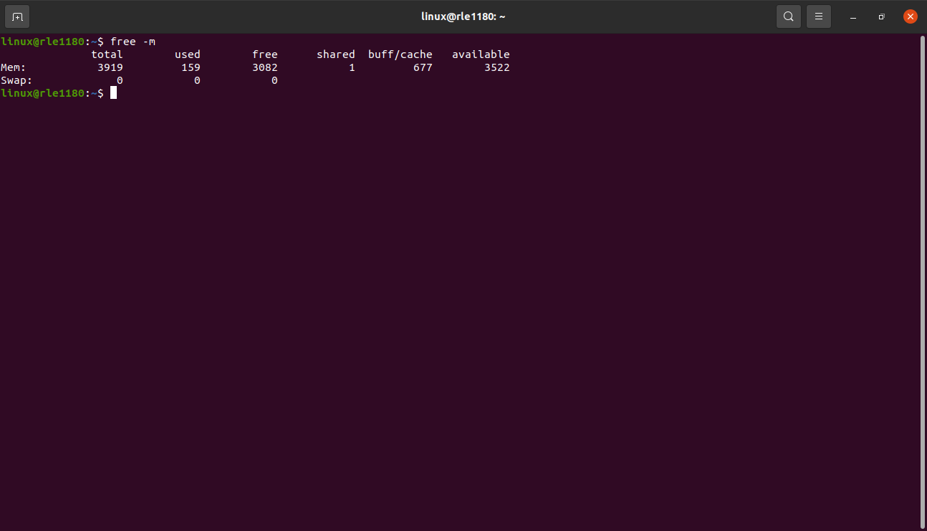
- total: this column indicates the total physical memory available in megabytes.
- Used: this column displays the amount of memory currently in use by the system.
- free: unused memory available for new processes.
- Shared: this column shows the memory used by shared memory.
- Available: it indicates the amount of memory that is available for starting new applications,without swapping.

2. **Investigating Memory Usage**

- in this task i run top command it displays adynamic list of processes and their resources usage
- To sort the processes by memory usage i pressed “ Shift + M” key.
- “ Shift + M”: This helps to order the process from highest to lowest memory usage.
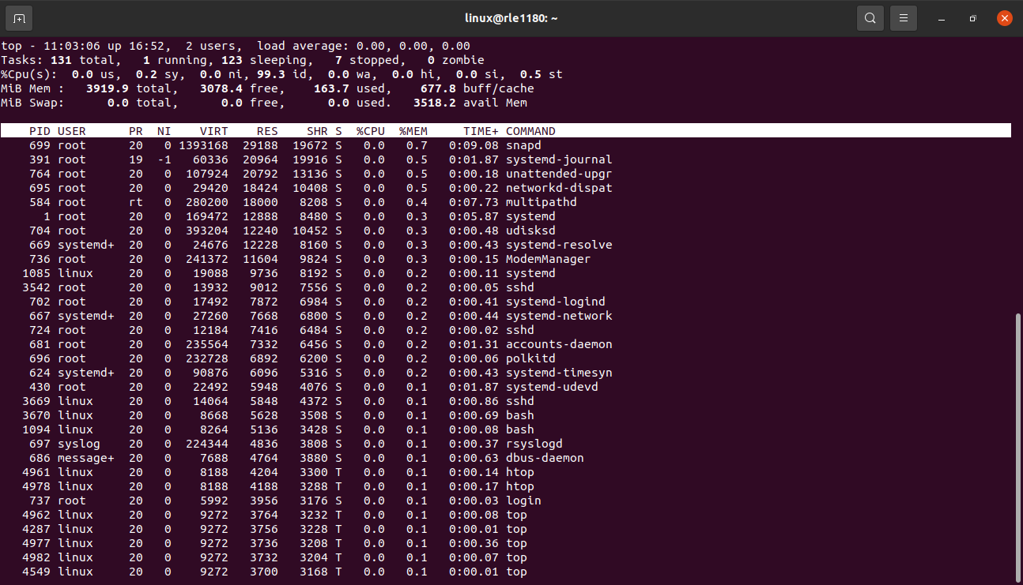
In the above picture i got highest memory usage processes of snapd.
- Snapd: it is a package management and software deployment tool.
- It is used for the deployment,management and removal of software packages called “snaps” on various linux distributions.
- Snaps are containerized software packages that include their dependencies,making them self-contained and independent of the underlying system’s libraries.

3. **Monitoring Memory Usage Over Time**

- The “vmstat” command in linux is used to display information about processes,memory,paging,block IO,traps and CPU activity.
- ‘vmstat 5’,it displays these statistics at regular intervals,with the specified delay between each display.
- The command ‘vmstat 5’ with a delay of 5 seconds would output information every 5 seconds,providing a snapshot of the system’s current performance.
Ex:
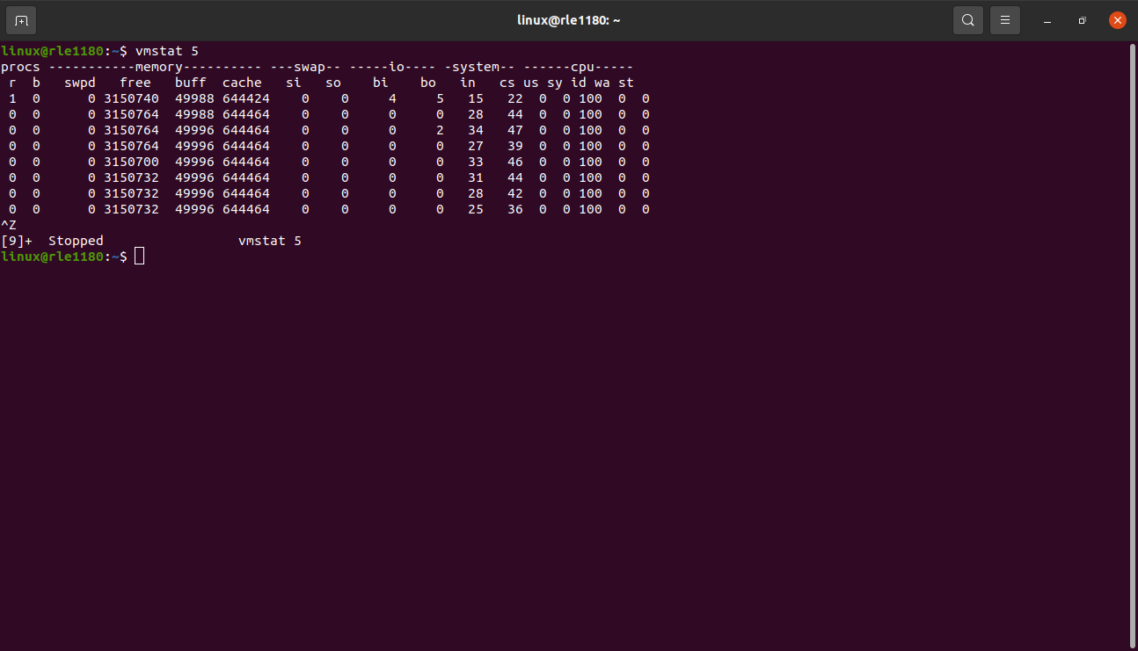
here is the data each column represents:

- procs: it gives the information about processes,including,the number of processes waiting to run and those currently running.
- Memory: memory-related statistics,including the amount of free memory,memory used for buffers and cache.
- Swap: gives information about swap space usage.
- Io : input/output statistics,such as blocks received and sent.
- System: information about interrupts and context switches.
- Cpu: CPU-related statistics,including the percentage of time spent in user space(us),system space(sy),idle(id) and waiting for i/o(wa).
- The ‘st’ column is specific to virtual machines and represents the time.stolen from a virtual machine.

4. **Identifying Memory Leaks**

- In this task i installed ‘valgrind’
ex : sudo apt install valgrind.
- created a c file named ‘ memory_leak.c ’.
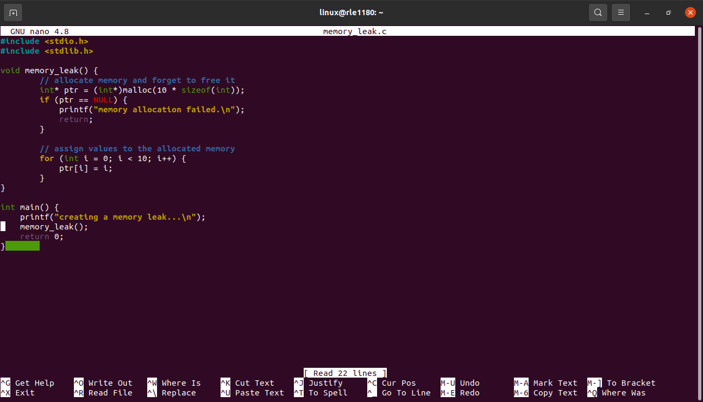
- compile your c program with debugging sysmbols
gcc -g -o your_program your_program.c
ex: gcc -g -o memory_leak memory_leak.c
- run your program with valgrind command.
Valgrind –leak-check=full ./your_program.
Ex: Valgrind –leak-check=full ./memory_leak.
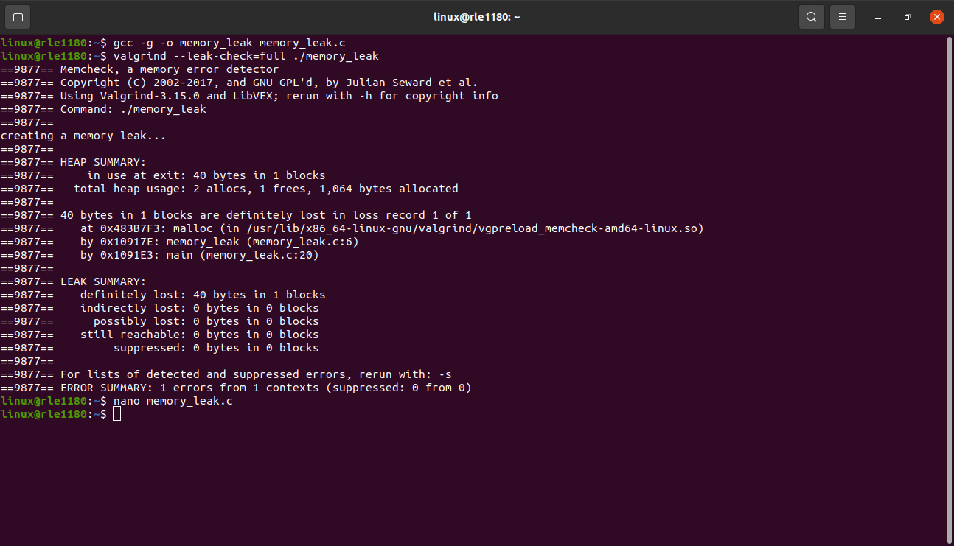
5. **Optimizing Memory Usage**

- optimizing memory usage in a program is crucial for improving its performance and efficiency.
- Using the ‘pidstat’ command can be used to mointor individual process resource usage.
Ex: the following command can be used to monitor memory usage.
‘pidstat -r’
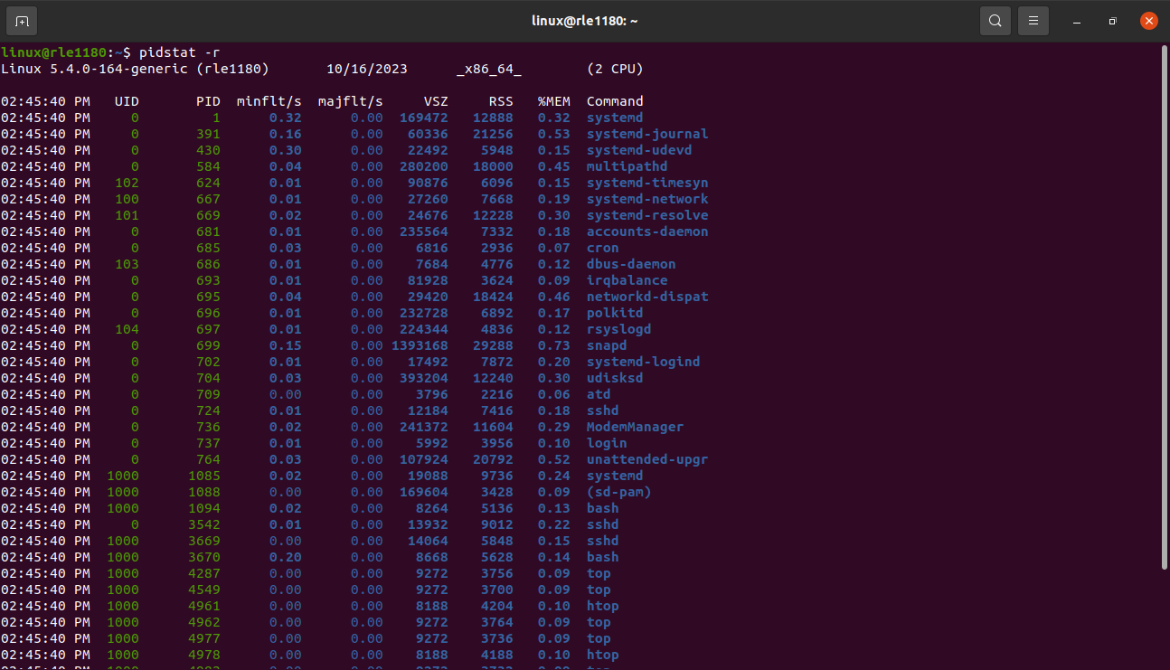

6. **Documentation and Reflection**

- memory management is a crucial aspect of computer systems and software that invloves the allocation,utilization and deallocation of a computer’s memory resources.
- Memory allocation: memory management begins with the allocation of memory resources to various components of the computer system,including the operating system,applications and data.
- Memory deallocation: memory management is responsible for reclaiming memory that is no longer needed.
- Swapping and paging: memory management can involve swapping data in and out of physical memory and onto disk storage.

